DC线输出IT/家电电源系列
特点 Features:
100-240VAC Universal Input
Single Output to 160W Max
Regulated Output with Low Ripple Noise

机械细节 Mechanical Details
Case Dimensions | L180*W70*H40mm
桌面式
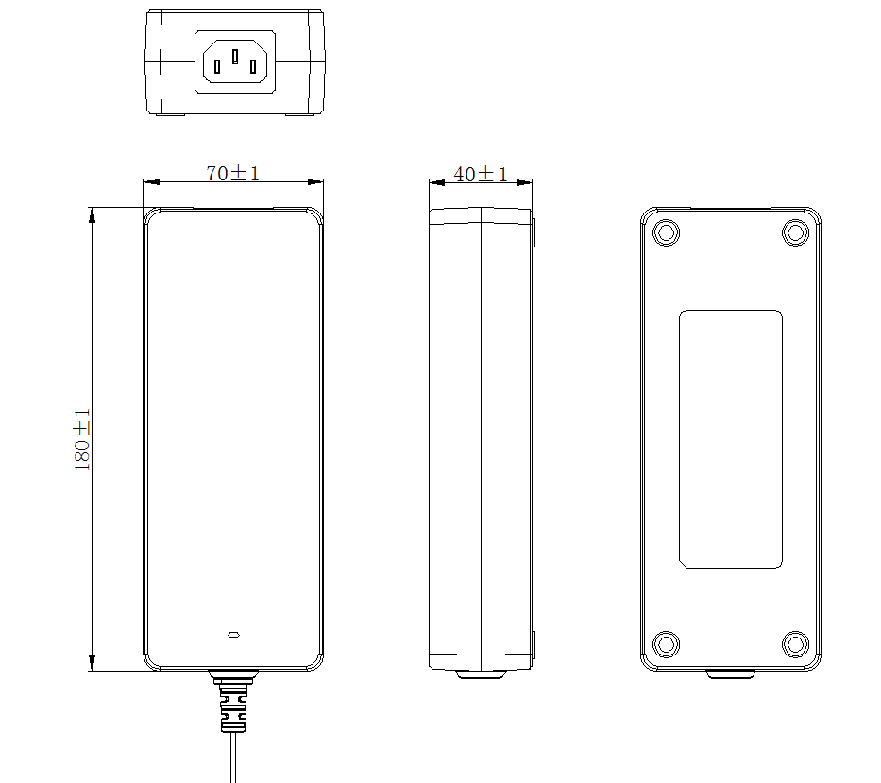

输入输出/Input & Output
Model | I/P | O/P
Model | I/P | Voltage | Current | Watt
HNxxxyyyWv | Voltage：100-240 VAC  Line Frequency：50/60Hz  Current：2.2A Max. | 12.0-48.0V | 0.01-12.5A | 160W(Max)

保护 Protection
Overload | 110-200% rated output power,auto recovery(hiccup mode)
Over Voltage | 150-200% rated output Voltage,auto recovery(hiccup mode)
Short Circuit | auto recovery(hiccup mode)

安规认证 / Safety Approvals
UL62368-1;UL1310;FCC Part 15 Subpart B Class B；
IEC/EN62368-1;IEC/EN61558-2-16;IEC/EN60335-2-29;
EN55032;EN55014-1;EN55035;EN55014-2;
GB4943.1-2011;GB/T9254-2008;GB17625.1-2012；
GB4706.1-2005;GB/T2099.1-2008；
J60950-1(H27);J55022(H22)；
J61558-1(H26)&J61558-2-16(H26);J55014-1(H27);
J60335-1(H27) J60335-2-29(H27) J55014-1(H27)；
AS/NZS60950.1:2015;CIS PR32；
AS/NZS61558.1&AS/NZS61558.2.16;CISPR 14；
AS/NZS60335.1&AS/NZS60335.2.29;CISPR 14；
CNS13438;CNS14336-1;
CB CE GS ETL FCC CCC CQC PSE SAA RCM BSMI VI

电气性能 Electrical
Topology | Switching Flyback
Insulation resistance | Input ot output: 10MΩmin. At 500VDC
Dielectric Withstand | 3000Vac/60Sec @ Input to Output
Leakage Current | 0.25mA @ 2Pin Input
Ripple | 150mV Max
Transient Response | 0.5mS for 50%Load Change Typical
Holdup Time | 6mS Min @ 100Vac/60Hz Max load
Stand by power | 0.1W without load
MTBF | ＞50,000 hrs MIL-HDBK-217 at 25℃
USB or DC Cord | DC Cord

环境 Environmental
Operaturing Temperature | 0℃ to 40℃
Storage Temperature | -20℃ to 80℃
Relative Humidity | Operating:20% to 80% RH
Relative Humidity | Storage:10% to 90% RH
CoolingNatural | Yes

