FB壳
USB输出IT快充电源系列
特点 Features:
100-240VAC Universal Input
Single Output to 18W Max
Regulated Output with Low Ripple Noise

机械细节 Mechanical Details
Case Dimensions | L47*W38.5*H24.5mm
欧规、美规、日规、中规固定AC插脚
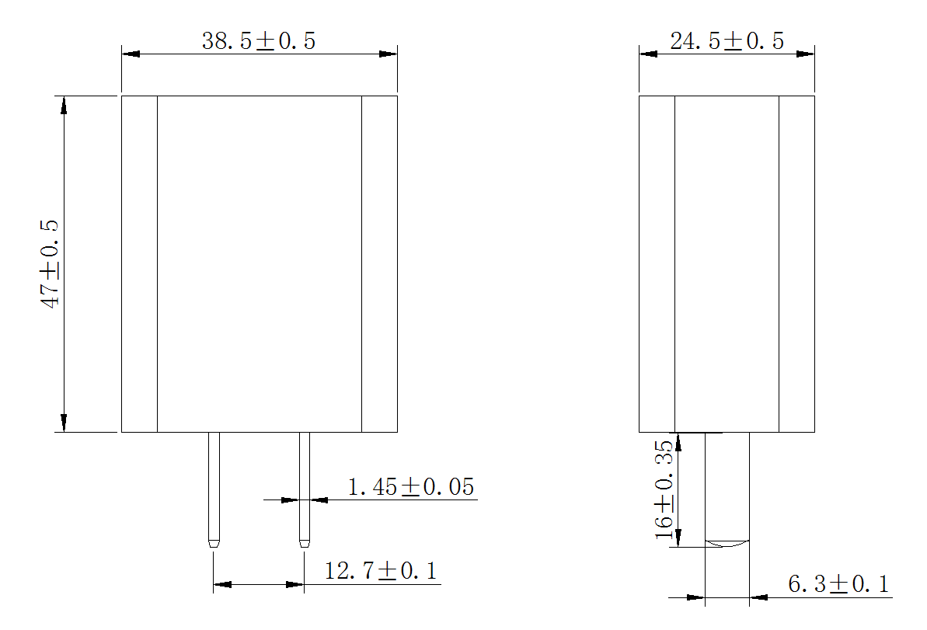

输入输出/Input & Output
Model | I/P | O/P
Model | I/P | Voltage | Current | Watt
HNFBQC3018wv | Voltage：100-240 VAC  Line Frequency：50/60Hz  Current：0.5A Max. | 5.0V | 0.01-3.0A | 18W(Max)
HNFBQC3018wv |  | 9.0V | 0.01-2.0A | 18W(Max)
HNFBQC3018wv |  | 12.0V | 0.01-1.5A | 18W(Max)

保护 Protection
Overload | 110-200% rated output power,auto recovery(hiccup mode)
Over Voltage | 150-200% rated output Voltage,auto recovery(hiccup mode)
Short Circuit | auto recovery(hiccup mode)

安规认证 / Safety Approvals
UL62368-1;FCCPart 15 Subpart B Class B
IEC/EN62368-1;EN55032;EN55035;
GB4943.1-2011;GB/T9254-2008;GB17625.1-2012
GB4706.1-2005;GB/T2099.1-2008；
J60950-1(H27);J55022(H22)
AS/NZS60950.1:2015;CIS PR32
K60950-1;KN22 KN24
QC3.0 CB CE GS ETL FCC CCC CQC PSE SAA RCM KC VI

电气性能 Electrical
Topology | Switching Flyback
Insulation resistance | Input ot output: 10MΩmin. At 500VDC
Dielectric Withstand | 3000Vac/60Sec @ Input to Output
Leakage Current | 0.25mA @ 2Pin Input
Ripple | 150mV Max
Transient Response | 0.5mS for 50%Load Change Typical
Holdup Time | 6mS Min @ 100Vac/60Hz Max load
Stand by power | 0.1W without load
MTBF | ＞35，000 hrs MIL-HDBK-217 at 25℃
USB or DC Cord | USB

环境 Environmental
Operaturing Temperature | 0℃ to 35℃
Storage Temperature | -20℃ to 60℃
Relative Humidity | Operating:20% to 80% RH
Relative Humidity | Storage:10% to 90% RH
CoolingNatural | Yes

